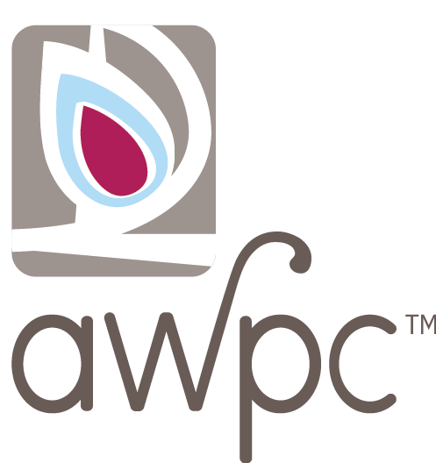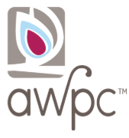





# 

***Another Way Pregnancy Center - A Woman’s Pregnancy Choice***

***31700 W. 12 Mile Road, Suite 230***

***Farmington Hills, MI 48334  
248-471-5858***

Come for a tour, light refreshments, and lots of holiday spirit!

If your church is hosting a giving tree with AWPC tags, feel free to bring your gifts!